ELECTION PROTECTION SMARTPHONEAPP:

All you need to know about voting in the palm of your hand!
When it comes to registering and voting, having the right information can often mean the difference between casting a ballot and being left out of the process. Americans – particularly young people and communities of color – are much more accustomed to receiving information via their mobile phones. This election cycle, it’s vital for voters to be able to access key information right in the palm of their hand.

In order to meet the needs of the Digital Age, the Lawyers’ Committee for Civil Rights Under Law, National Association of Latino Appointed and Elected Officials Education Fund, New Organizing Institute, Rock the Vote and Verified Voting Foundation have joined forces to deploy the Election Protection Smartphone Application to provide all information and resources, in English and Spanish (branded Ya Es Hora), that voters need to fully participate in the 2012 elections.
The Election Protection App will is now available on all Smartphones (boh iPhones and Androids) and provides all the information and resources voters need to register and cast a meaningful ballot in the palm of their hands. The App allows voters to:
• Verify their registration;
• Register to vote;
• Look up their polling place;
• Review key voting rules and regulations for their state;
• See what type of machine they vote on; and
• Contact Election Protection via phone or email to report a problem or get answers.

It also allows schools to get a customized sign-up page (modeled on Rock the Vote widget) where you can track student registrations and follow up with customized emails or text messages to highlight key dates, like deadlines for them to help their friends register, early voting information, or campus Get Out the Vote events. To get your sign-up page, so you can distribute the app to your students, fill out this form:

http://signup.lawyerscommittee.org/p/salsa/web/common/public/signup?signup_page_KEY=6423
You can also get the generic sign-up form here, but that won’t allow your school to access the data

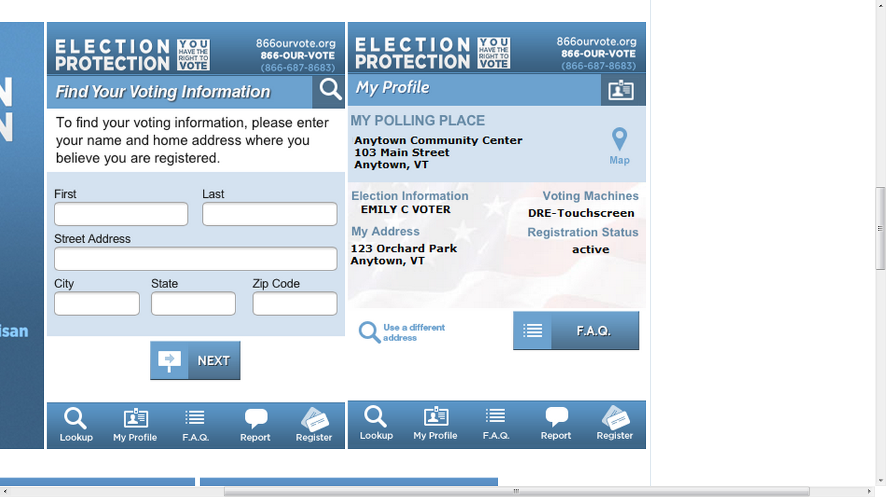
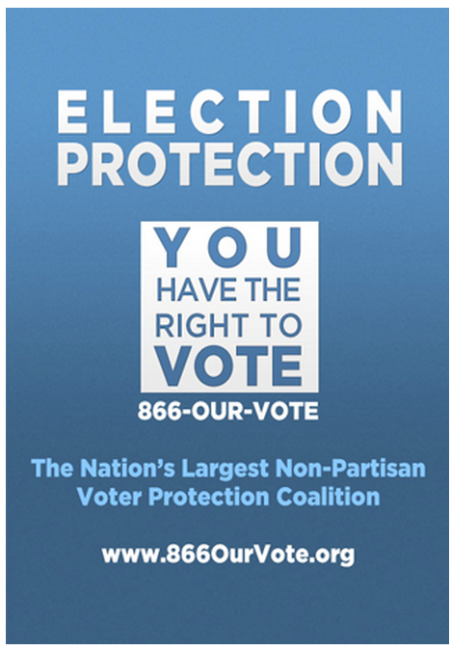

Sample SmartphoneApp Descriptions to send out
These are sample descriptions of the SmartphoneApp that you can send out. The ones below refer people to the generic URL for downloading, so if you want a custom URL for your school so you can send out tailored reminders and have access to the data for follow-ups, please use this form to secure it and then paste in the custom URL they’ll give you for your emails, Facebook postings, and Tweets.

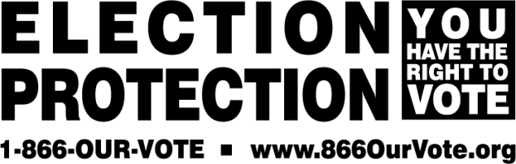

Election Protection SmartphoneApp
Online and Social Media Outreach Examples

We need YOU to help get the word out about the Election Protection SmartphoneApp! Below you will find sample Tweets, hashtags, Facebook posts, website postings and email blats to use for online and social media promotion of the EP App to help notify your members and followers about this new tool. For more information or to become an app partner please contact Chris Melody Fields at cfields@lawyerscommittee.org.

Twitter Outreach
Please use the following hashtags and tweets to help spread the word and get people to download the app.

Recommended Hashtags:
#EPApp #VotingRights #EP2012 #Vote2012 #GetRegistered #VerifyMyVote #Vote #MyVote #p2 #electprotect

Sample tweets:
Promotional Tweets:
Check out Election Protection App from @LawyersComm @NALEO @NewOrganizing @RocktheVote @VerifiedVoting #EPApp http://tinyurl.com/8bcdbh9

Election Protection SmartphoneApp: All you need 2 know about #voting in the palm of your hand! #EPApp http://tinyurl.com/8bcdbh9

Need to find out where you vote in Nov? Download the Election Protection SmartphoneApp! #EPApp http://tinyurl.com/8bcdbh9 #electprotect

Are you registered to vote in 2012? Use the Election Protection SmartphoneApp to find out! #EPApp #GetRegistered http://tinyurl.com/8bcdbh9

Questions about voting? Use the @866OurVote SmartphoneApp! http://tinyurl.com/8bcdbh9 #ElectProtect #EPApp

Educate & empower yr friends & family 2 vote with the Electon Protection Smartphoneapp http://tinyurl.com/8bcdbh9 #EPApp

Sample Facebook Posts:
Check out the Election Protection SmartphoneApp from Lawyers’ Committee, NALEO, New Organizing Institute, Rock the Vote, and Verified Voting. All you need to know about voting at the palm of your hand. http://tinyurl.com/8bcdbh9

Check your registration status, find your polling place, get voting related questions answered with the Election Protection SmartphoneApp from Lawyers’ Committee, NALEO, New Organizing Institute, Rock the Vote, and Verified Voting. http://tinyurl.com/8bcdbh9

A lot is riding on the 2012 Election, download out the Election Protection SmartphoneApp to verify registration, find your polling location, get an FAQ about voting issues in your state, and much, much more!!! http://tinyurl.com/8bcdbh9

Want to vote in the upcoming election? Don’t know if you are registered to vote? The Election Protection SmartphoneApp can help! Download it today! http://tinyurl.com/8bcdbh9

Website Posting Sample:
The 2012 election cycle is in full swing and we want to make sure you have all the information you need in order to cast a ballot. The new Election Protection Smartphoneapp gives you all you need to know about voting in the palm of your hand! The app is available in both English and Spanish will be available to iPhone, Android, and Blackberry users.

After downloading the app, users will be able to:
- Verify their registration and register to vote;
- Look up their polling place;
- Review key voting rules and regulations for their state;
- See what type of machine they vote on; and
- Contact Election Protection via phone or email to report a problem or get answers to their questions.

You need to be equipped and informed when heading to the polls this year and this app can help. Lawyers’ Committee for Civil Rights, NALEO Education Fund, New Organizing Institute Education Fund, Rock the Vote and Verified Voting have collaborated to provide this Smartphoneapp free of charge. Click here to download the Election Protection SmartphoneApp to your phone.

Sample Email Blast #1:
Subject: As you head to the polls in 2012, a new Smartphoneapp to help answer your questions!

Email:

Dear [Insert name]:

More and more people access information through their mobile devices so in 2012 Election Protection is going to meet voters where you are—your phone. The Election Protection SmartphoneApp will help you navigate through the voting process. Click here to download the app.

The Election Protection SmartphoneApp will be available in both English and Spanish and allow you to:
- Verify your registration and register to vote;
- Look up your polling place;
- Review key voting rules and regulations for your state;
- See what type of machine you will vote on;
- Receive notifications of late breaking news affecting voting in your area; and
- Contact Election Protection via phone or email to report a problem or get answers to your questions.

With states passing laws rolling back early voting dates, making it harder for community-based organization to register voters, and requiring voters to present government-issued photo IDs in order to cast a ballot, it is crucial to provide resources to allow voters to access and receive real-time information. The Election Protection SmartphoneApp will provide all the information voters need in the palm of their hand.

Download the Election Protection App. If you have questions or problems voting don’t forget to call 1-866-OUR-VOTE (1-866-687-8683) or 1-888-VE-Y-VOTA (1-888-839-8682).

Thanks,

Insert org info

